Login to PLYSSQL147P.

Open SQL Server Management Studio.

Select the database **Allergan.**

**Generating History Data:**

1. Run the below query.

This will display the latest Data Month name for Finland. Here, latest month is M112012.

select * from Allergan_Load_Details where country = 'No'

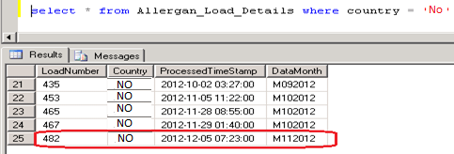

2. Run the Below query with the Latest Data Month Load Number.

This will display the backup data of M112012 Which was loaded in last production run.

select * from Allergan_Output_History where loadNumber = 465

3. Run the Below SP which will load the latest production period data from Production

Server (PLYSSQL147P) to Development Server (PLYSSQL146D)

**EXEC dbo.usp_Populate_History_Data 'NO','MmmYYYY'**

where mm = Current Production Month Number (01, 02, ... 11,12)

and YYYY = Current Production Year.

4. Run the below query to check whether the latest production period data loaded or not

select * from Allergan_Load_Details where country = 'No'.



5. Run the **MergePacks.exe** from D:\FTP\MergePacks tool\

6. Click on Build Report

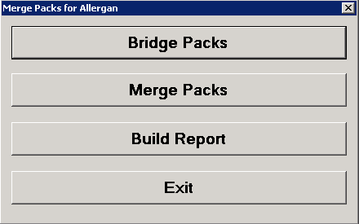

7. Select Country = NO and Previous Build = Previous Month. Click OK

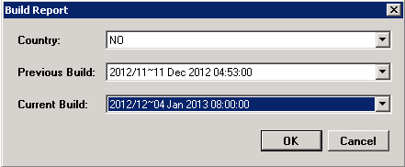

8. After successful run Below window will appear and the History Correction Report will generate at D:\FTP\MergePacks tool\Reports

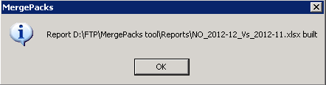

9. Copy the report file and backup at D:\FTP\MergePacks tool\Reports\YYYY\YYYYMM

where MM = Current Production Month Number (01, 02, ... 11,12)

and YYYY = Current Production Year.

10. Download the history excel file into Local and rename

History_Corrections_Norway_monYYYY.xlsx

where mon = Current Production Month Name

and YYYY = Current Production Year.

This file should mail to Allergan with delivery mail.

**Input CUBE vs Output Data:**

[N.T only Norway .abf file has a problem. So we have to change it business intelligence. Open BI with administrator thn select server and database. Thn cubes .. calculation.. view script. ]

1. Downloadthe output file **Norway_MMYYYY.csv** and input file **NPI_NO_M_ALLERGAN_C20100-21401.abf abf**  in local pc.
2. Load **NPI_NO_M_ALLERGAN_C20100-21401.abf** cube in local pc **Analysis server** as below

* Open **sql server management studio** then click connect.

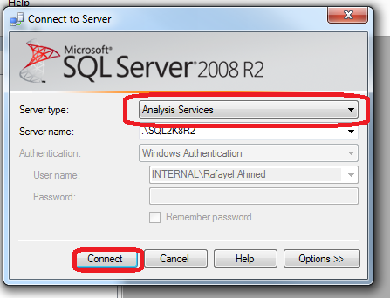

* create new data base as **Allergan_Norway_MMYYYY**

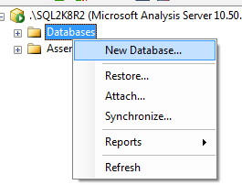

* restore database: click on restore

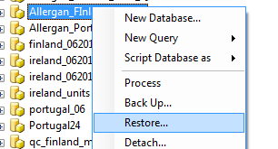

-Select the abf file then select database ..tick the db overwrite then click ok.

- 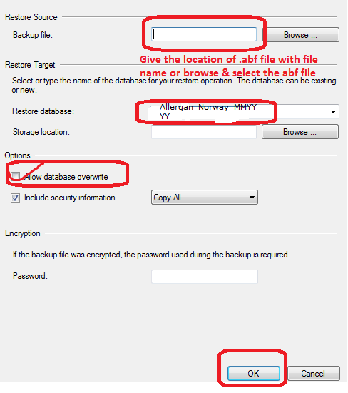

-database will restore.

Open BIDS

**select Norway Cube -> Calculations -> Script View**

**3. QC**

Open the output csv file **Norway_MMYYYY.csv** with Textpad. Select 3 records for 3 measure Counting Units, Units and Values for a particular Product and SKU which have >0 values in latest month

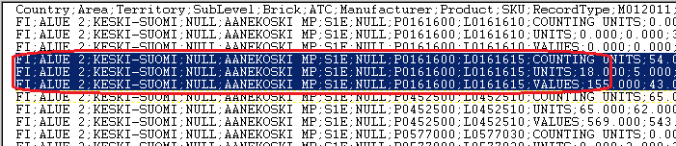

And then create a text file **QA_Norway_YYYYmm.txt** and copy that 3 records in **QA_NORWAY_YYYYmm.txt**

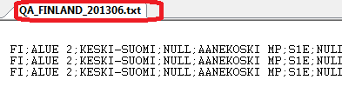

1. click browse

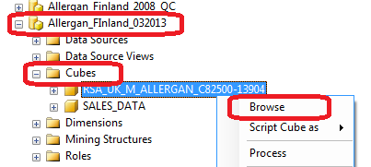

1. select **latest month** ,**geo, and product.**

Drag item in arrow.

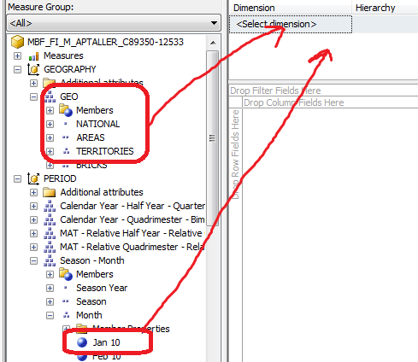

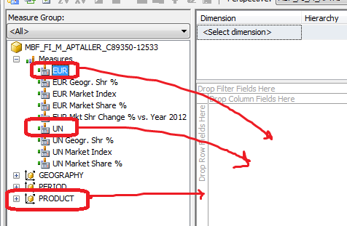

4.match the result with file **QA_FINLAND_YYYYmm.txt**

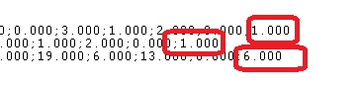

5.

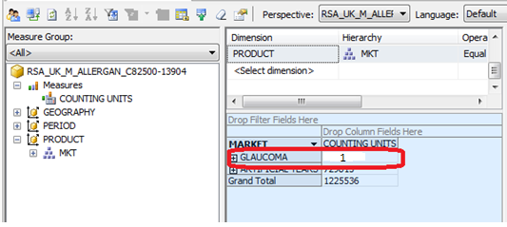

6.process in done.